Project Code Submission Changes Document

Changes in our use of Cloud Platform:
For this project, we initially planned to use AWS as our cloud provider. However, after careful evaluation of our budget constraints and the need for cost minimisation, we decided to switch to Google Cloud Platform (GCP). GCP provided comparable functionality for our requirements at a more cost-effective price point, aligning better with our project’s financial goals while still ensuring high performance and scalability.
Additional Features:
Stock Inventory Management
This system is designed to track inventory in real-time, ensuring efficient stock monitoring. When a specific equipment item falls below the threshold level, the system automatically highlights it in red and notifies the admin via the dashboard. If an item is approaching its threshold, it is highlighted in yellow, providing a proactive alert to address inventory needs before depletion.
Announcements
The announcements feature enables branch managers to communicate important updates or common notifications to their team members effectively. Through this section, managers can ensure their staff stays informed about key messages or organizational updates.
User Request Handling
Staff members can request updates to their user credentials, such as ID, email, or password, through a dedicated form. This form is sent to the admin with a priority level for review. The admin can then manage the request by marking it as "In Progress" or "Complete," streamlining the process for user account updates.

Below is an updated overview of the hierarchy structure of the users within the application:
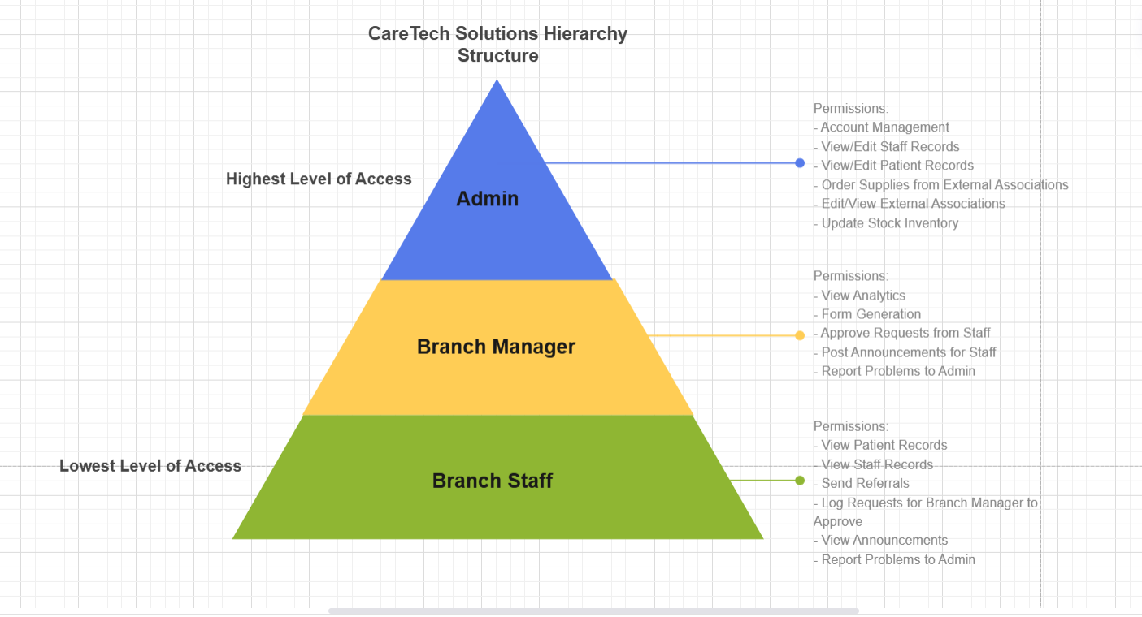
Below is an updated Cloud Architecture diagram:
